CITI: RCR Instructions
Table of Contents
Account Set-up and First Time Core Training - 1 -
Adding the RCR Module to an existing Drexel CITI Account - 9 -
Associating a previous CITI account with Drexel - 12 -

The National Science Foundation’s (NSF) Responsible Conduct of Research (RCR) training requirement has expanded to include all faculty and senior personnel supported by NSF funding for proposals submitted or due on or after July 31, 2023. RCR training is intended to help inform the university research community of the wide range of ethical and professional issues that must be considered to ensure a climate of research integrity. Drexel University requires all researchers to engage in ethical research practices based on regulatory standards and professional guidelines of the respected field.
This instruction aims to provide a step-by-step process on how to access the CITI training module for Responsible Conduct of Research as a first-time CITI user, a returning CITI user at Drexel, as well as how to associate CITI training completed under a previous Institution with Drexel University. CITI RCR training completed at a different Institution within the past 4 years will be accepted as documented RCR training if the individual’s CITI account is linked with Drexel University.

Account Set-up and First Time Core Training
Follow these instructions if you are new to the CITI program.
- Visit the CITI website to get started.
Research, Ethics, and Compliance Training | CITI Program

- Once on the home page, navigate to the upper right and click on “Register” box.
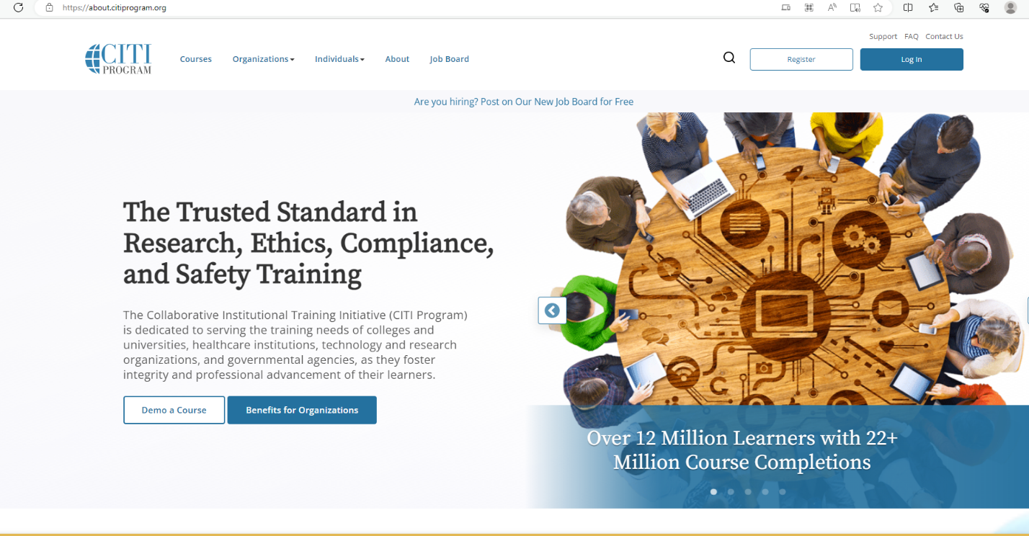

- After clicking “Register”, choose “Select Your Organization Affiliation”.
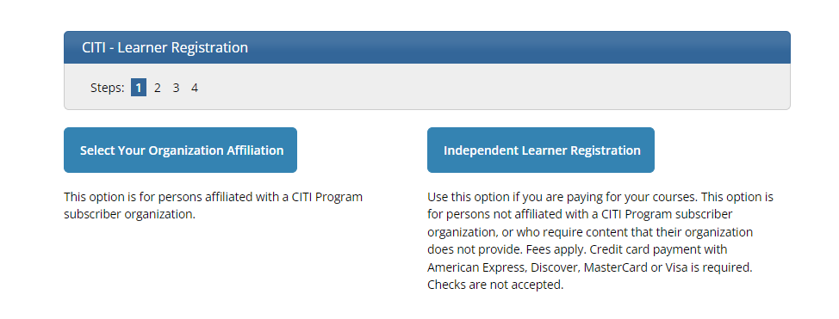
- Type in Drexel University and select Drexel University from the drop-down list. Then agree to the Terms of Service and Privacy Policy as well as affirm to being an affiliate of Drexel University by checking the boxes below. Lastly, click the “Create a CITI Program account” box.
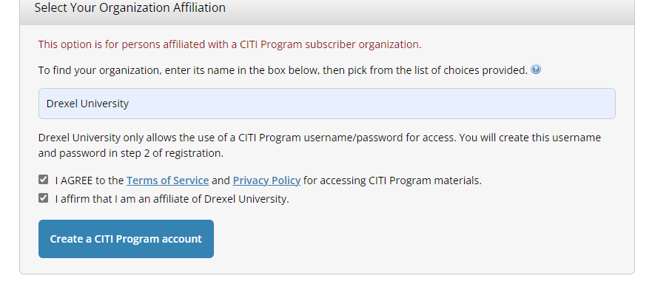

- Next fill in personal information. Please keep in mind, it is advantageous to include a second email address (personal) in order to continue the same learner transcript at future institutions. After completing the personal information, select the “Continue to Step 3” box.
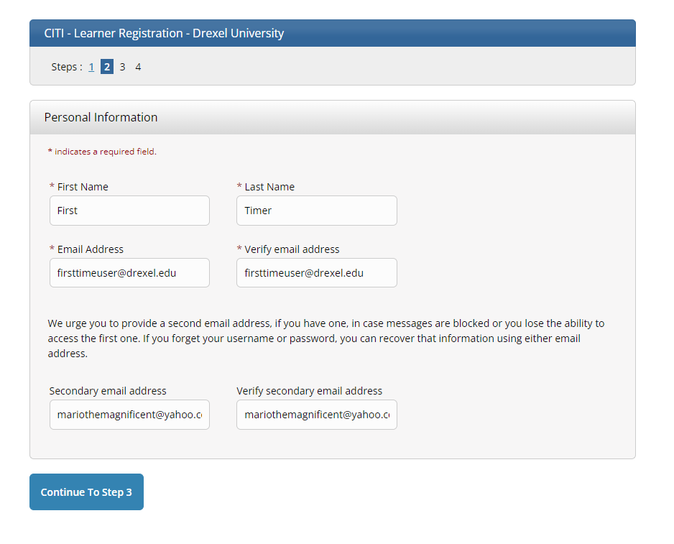

- Create a username and password along with a security question and answer. Once completed, click the “Continue to Step 4” box.
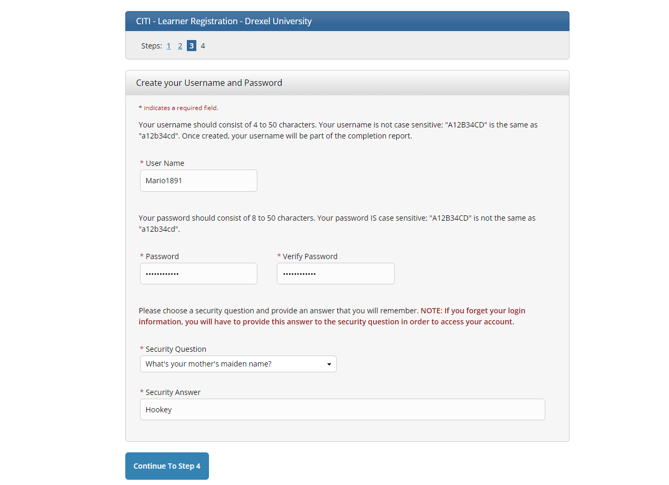

- Select Country of Residence and Opt In or Opt Out of additional contact about courses and services from CITI. Once these two fields are completed, click the Finalize Registration box.
***TIP: A “Save Password” window may pop up once navigated to this page. Accepting is up to personal preference if using a secure device.
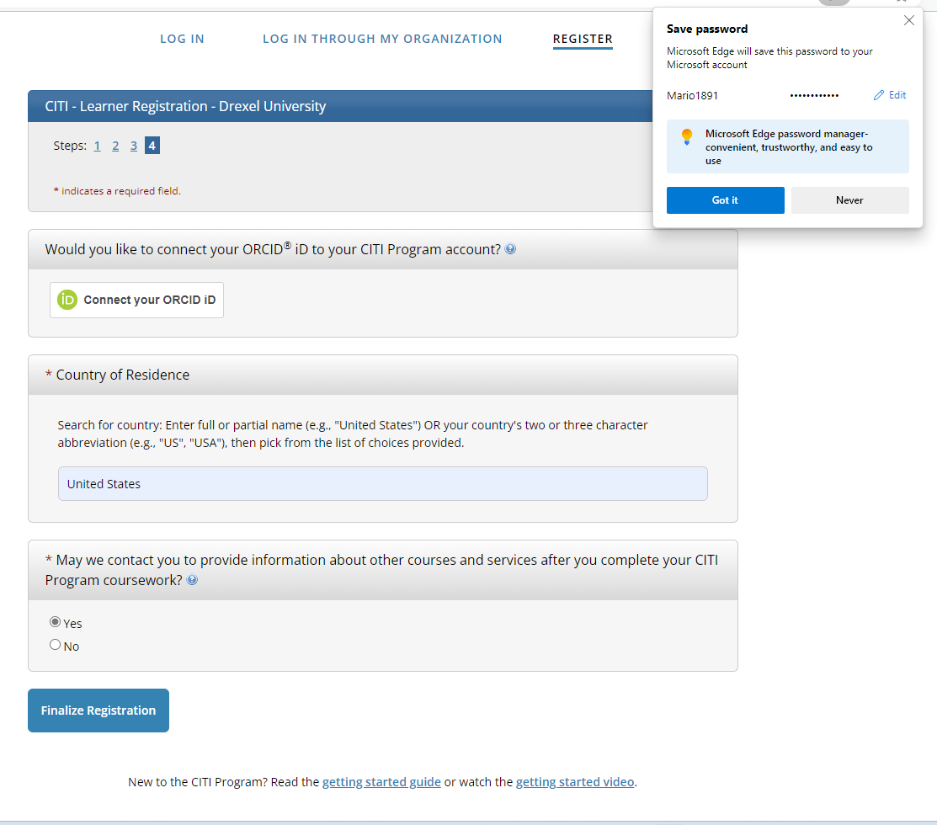

- Continue to create your CITI user profile, including selecting CE preferences, your institutional email address, department, role, as well as your personal account profile.

- On your “My Courses” page, select to “View Courses” for Drexel University.
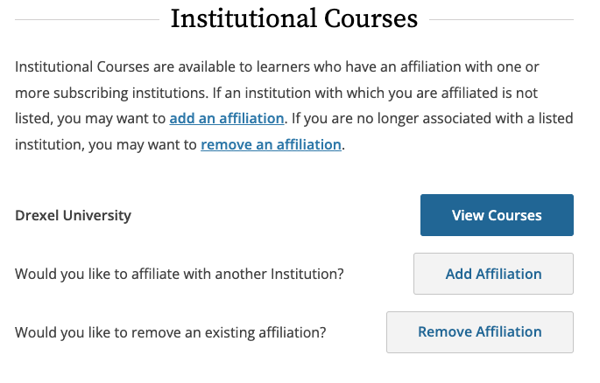

- Select “Add a Course” from one of the two options below.
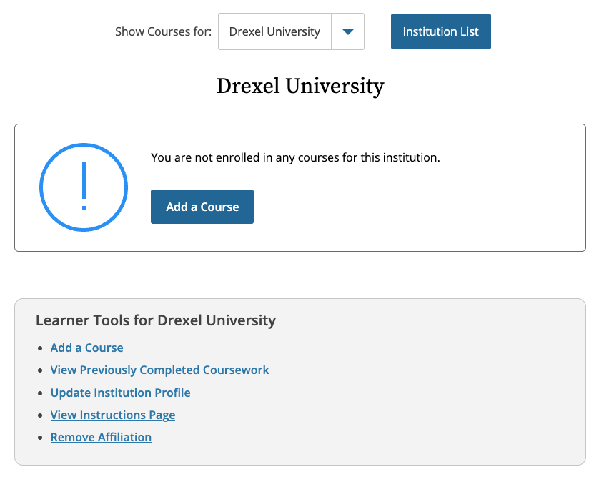

- From the list of available courses, select “Responsible Conduct of Research (RCR) Courses”.
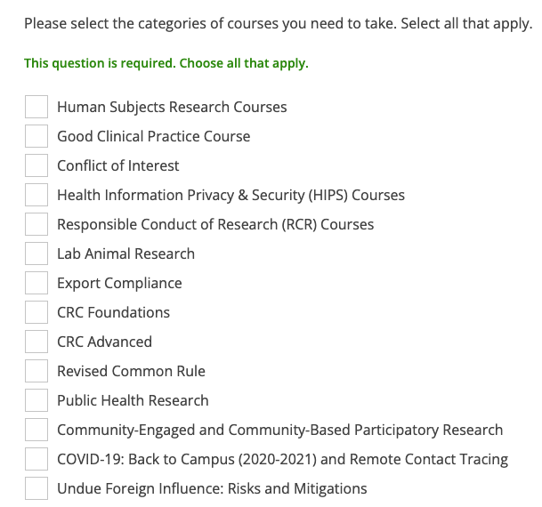

- Select the applicable RCR learner group based on your research role.
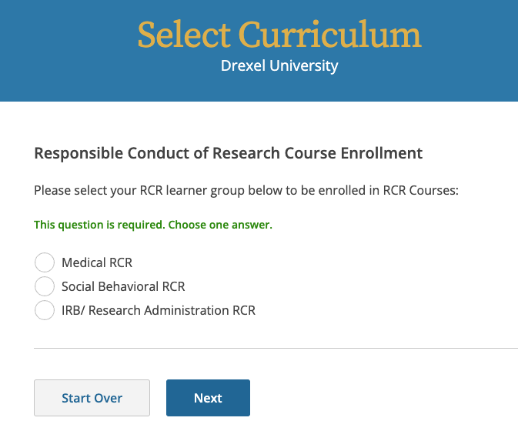

- The assigned RCR module will now appear in your “Courses Ready to Begin” list under your personalized Drexel University assigned courses. Select “Start Now” to begin and complete the training.

Adding the RCR Module to an existing Drexel CITI Account
Follow these instructions if you have already completed CITI training through a Drexel account and need to add the RCR module.
- Visit the CITI website to get started.

Research, Ethics, and Compliance Training | CITI Program

- Log into your CITI account.
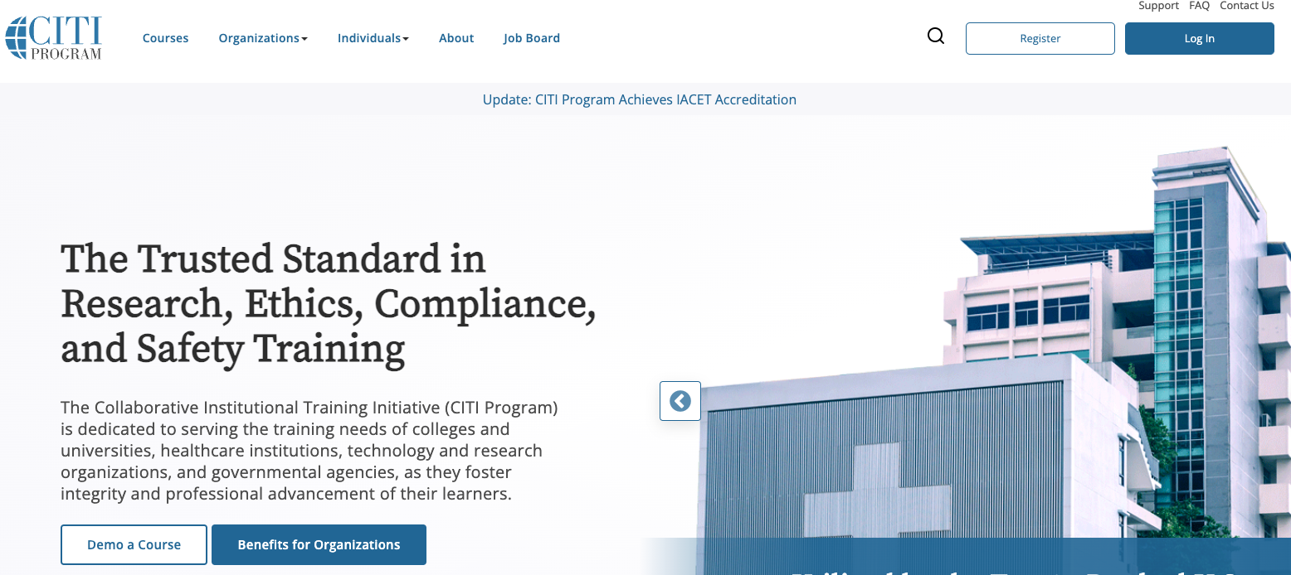

- On your “My Courses” page, select to “View Courses” for Drexel University.
- All assigned and completed courses will be listed. At the bottom of the page, under Learner Tools for Drexel University, select “Add a Course”.
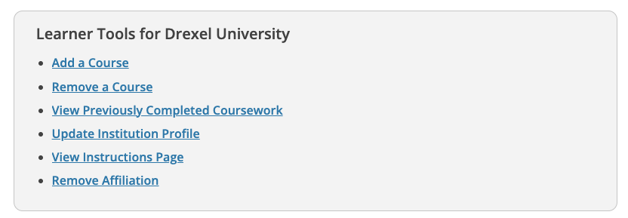
- From the list of available courses, select “Responsible Conduct of Research (RCR) Courses”.

- Select the applicable RCR learner group based on your research role.
- The assigned RCR module will now appear in your “Courses Ready to Begin” list under your personalized Drexel University assigned courses. Select “Start Now” to begin and complete the training.

Associating a previous CITI account with Drexel
Follow these instructions if you have already completed CITI RCR training through a personal account or one associated with a previous Institution.
- Visit the CITI website to get started.

Research, Ethics, and Compliance Training | CITI Program

- Log into your CITI account.

- On the home page, click on “Add an Affiliation”.
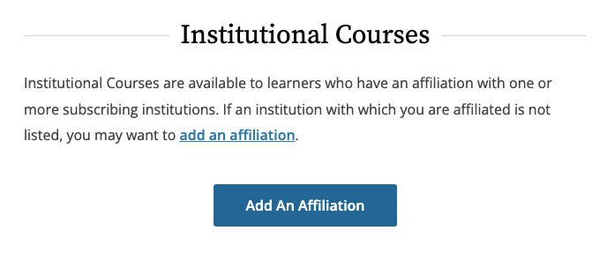

- Type “Drexel University” in the text field to find the Institution. Agree to the Terms of Service and affirm affiliation with Drexel University.
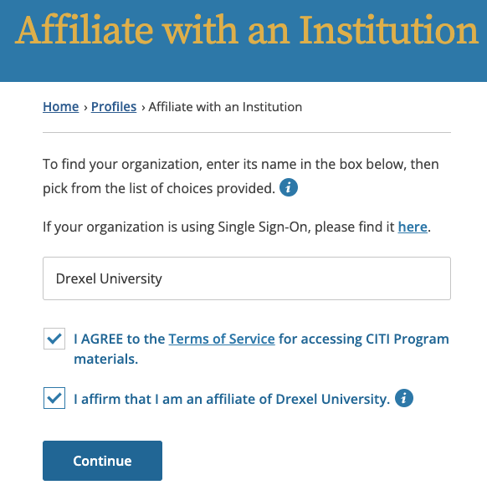

- Complete the required Profile fields, including institutional email address, department, and role.

- Select any applicable training from the list of available courses. Please note, that previously completed CITI courses will be viewable in the “My Records” tab. CITI RCR training completed at a different Institution within the past 4 years will be accepted as documented RCR training if the individual’s CITI account is linked with Drexel University.

